A1334-Asia-Indus-Bowl-Three Gazelles-6x7 Grid-Terracotta-2600-1900 BCE

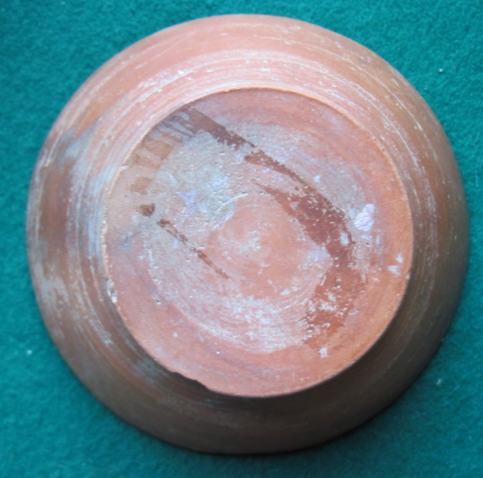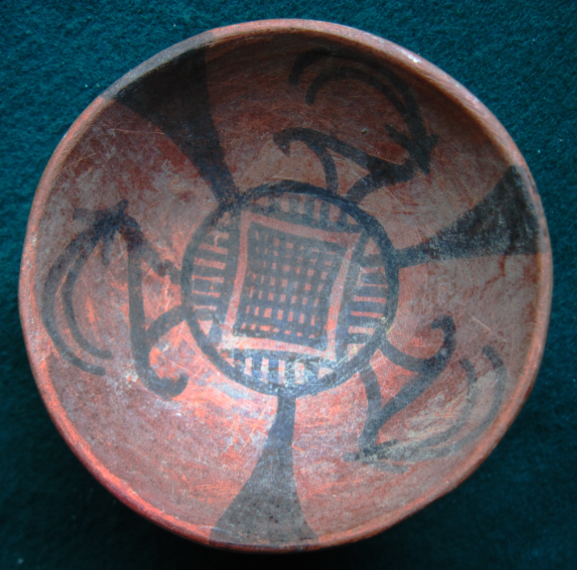

Figs 1-2. Indus-Bowl-Three Gazelles-6x7 Grid-Terracotta-2500 BCE

**Case no.: 3**

**Accession Number: A1334**

**Formal Label:** Indus-Bowl-Three Gazelles-6x7 Grid-Terracotta-2500 BCE

**Display Description:**

This gazelle symbolism suggests Vayu, a primary Hindu deity, lord of the winds. “The other atmospheric gods are his associates: Vayu-Vatah, Parjanya, the Rudras and the Maruts. All of them are fighters and destroyers, they are powerful and heroic” (Bhattacharji 1984). He is also father of Bhima and the spiritual father of Hanuman. He is also known as Anil ("Air, Wind"), Vyān (Air), Vāta ("Airy Element"), Tanun (The Wind), Pavan ("Purifier"), and Prāṇa ("Breath"). All these associations suggest a spiritual element (Raju 1954). This challenges the Harappan/Indus hypothesis by suggesting that the Indus Valley civilization is Vedic and hence Indic thereby destroying the Aryan invasion theory.

**LC Classification:** DS425

**Date or Time Horizon:** 2600-1900 BCE

**Geographical Area:** Indus River Valley

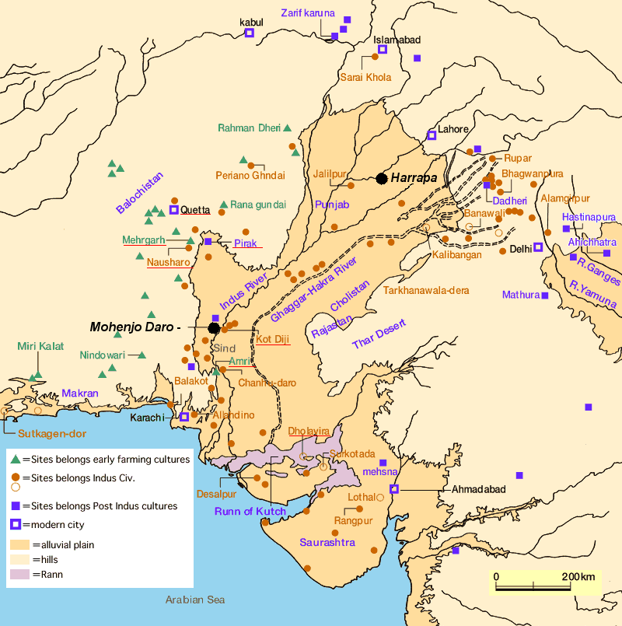

Fig. 13. Map of Indus sites from https://encrypted-tbn0.gstatic.com/images?q=tbn:ANd9GcSnoolUCyM4saSet1fqKCqzYEWJhfDBzJsATILKpXYgG8P2maLY.

**Map, GPS coordinates:** [27°19′45″N 68°08′20″E](https://tools.wmflabs.org/geohack/geohack.php?pagename=Mohenjo-daro&params=27_19_45_N_68_08_20_E_type:landmark)

**Cultural Affiliation:** Indus Civilization

**Media:** Terracotta, Black Pigment

**Dimensions:**

**Weight:**

**Condition: original**

**Provenance:** unknown

**Discussion:**

**References:**

[Bhattacharji](https://www.google.com/search?tbo=p&tbm=bks&q=inauthor:%22Sukumari+Bhattacharji%22), Sukumari. 1984 *Literature in the Vedic Age:* *The Saṃhitās*. New Delhi: K.P. Bagchi.

Jansen, Eva Rudy; Tony Langham. 1993. *The book of Hindu imagery: The Gods and their Symbols*. New Delhi: Binkey Kok Publications.

Raju, P.T. 1954. “The concept of the spiritual in Indian thought,” *Philosophy East and West*, 4 (3): 195–213,